**VIDYASAGAR TEACHERS’ TRAINING COLLEGE**

**MIDNAPORE, PASCHIM MEDINIPUR, WEST BENGAL**

LINK OF VIDEOS

https://bedtrainees2024.gnomio.com/course/view.php?id=3

MOOCS COURSE

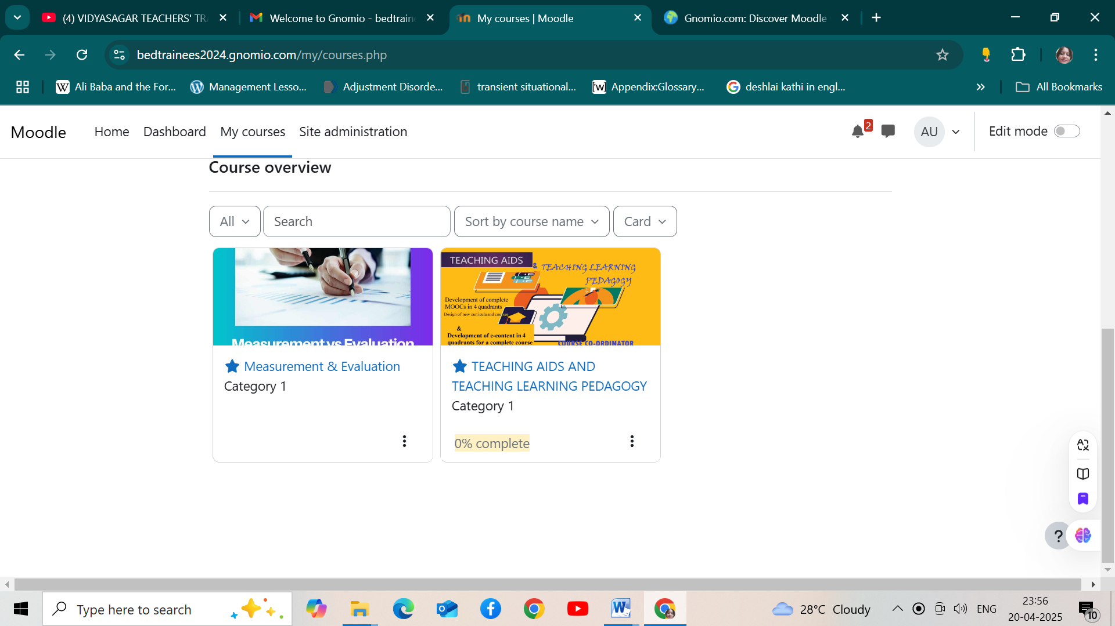<https://bedtrainees2024.gnomio.com/course/view.php?id=2>

TEACHING AIDS AND TEACHING LEARNING PEDAGOGY

https://bedtrainees2024.gnomio.com/course/view.php?id=3

Measurement & Evaluation

MOOCS COURSE